|  |  |
| --- | --- |
| USER GUIDE  Jan Suvidha Kendra(JSK) | jharkhand municipal services    Sparrow Softech Pvt. Ltd |

Imp Note: Web Slides shown in this guide is for illustrative purpose only, actual website may differ…

Preface – About This Guide

This guide is intended for new users with little or no experience using the JHARKHAND MUNICIPAL Web Interface. The goal of this document is to give a broad overview of the summary of functions listed in JHARKHAND MUNICIPAL Web Interface and some basic instructions on how to set up and administer a list. This document will concentrate on demonstrating interaction with JHARKHAND MUNICIPAL Web Interface.

The following documentation conventions have been used in this manual:

* Web Screen Shots are provided of some randomly selected functions.
* Numbers with indicating arrows in red, blue, green and white are shown to understand the concept of interface.
* Clickable buttons will be bold.
* Screen Captures have been cropped and or edited for emphasis or descriptive purposes.

**Contacting Sparrow Softech Pvt. Ltd**

**Support**

Sparrow Softech recognizes that the information in this guide are not going to solve every problem you may face. We are always willing to help diagnose and correct problems you be having with your JHARKHAND MUNICIPAL web interface.

Should you have any queries please feel free to contact our technical team, we will be glad to provide you an all-round support.

Visiting the home screen…

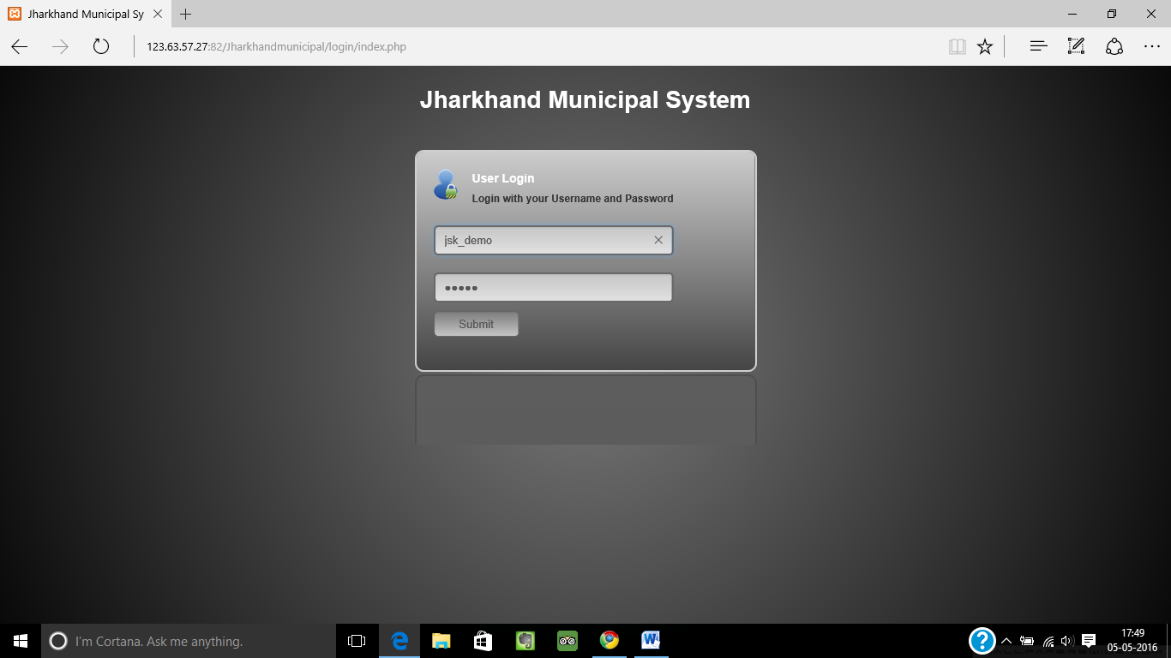

◆

❖

⬥

◆

Visit the admin panel by logging to jharkhandsuda.net/login

❖

Enter the admin user id and password

⬥

Click **Submit** button to view the dashboard

Dashboard’s View…

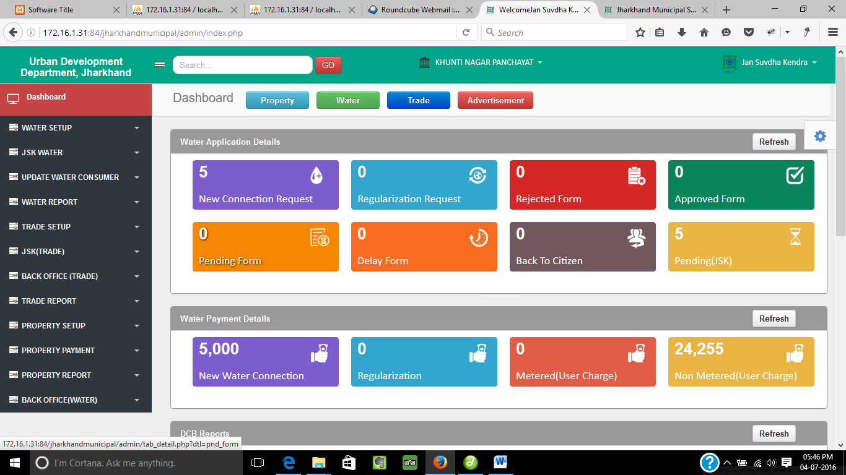

⬥

❖





◆





◆

Click the downwards pointer to see the user profile, settings etc. Search the web application by entering keywords and click **GO** button.

❖

⬥

Click on Your desired module i.e . Property etc. Click **o**n **individual tabs** to see the required details.



****

Click to choose the desired municipal corporation. Different menu’s carrying different admin rights(Trade).

Trade Setup

Trade Setup

Range Type…

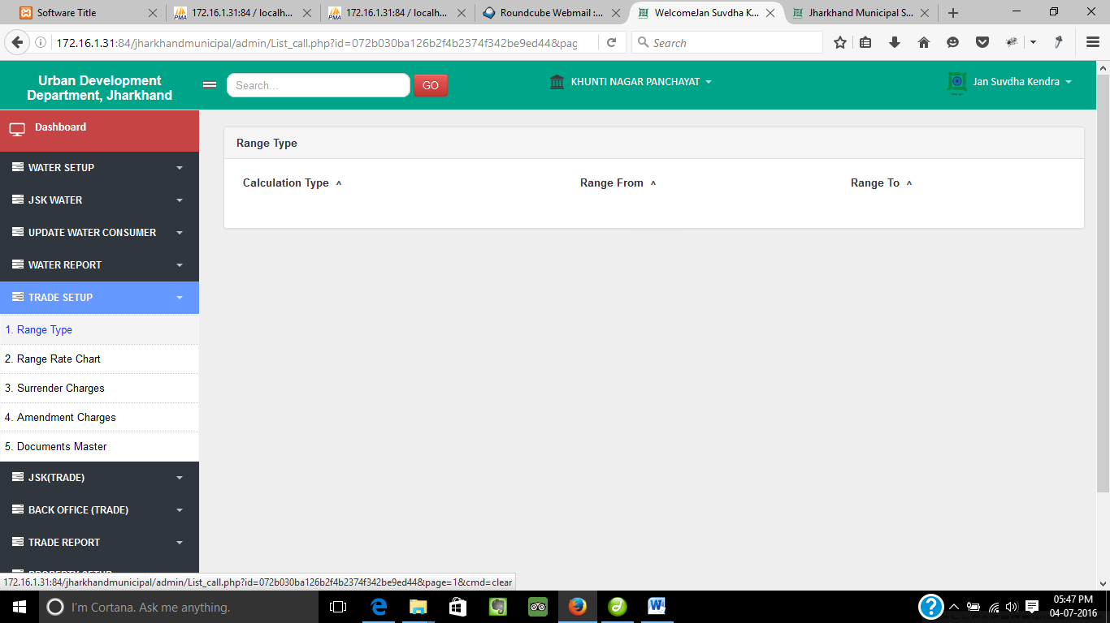

◆

◆

Click on **Range Type** to see the list of range type.

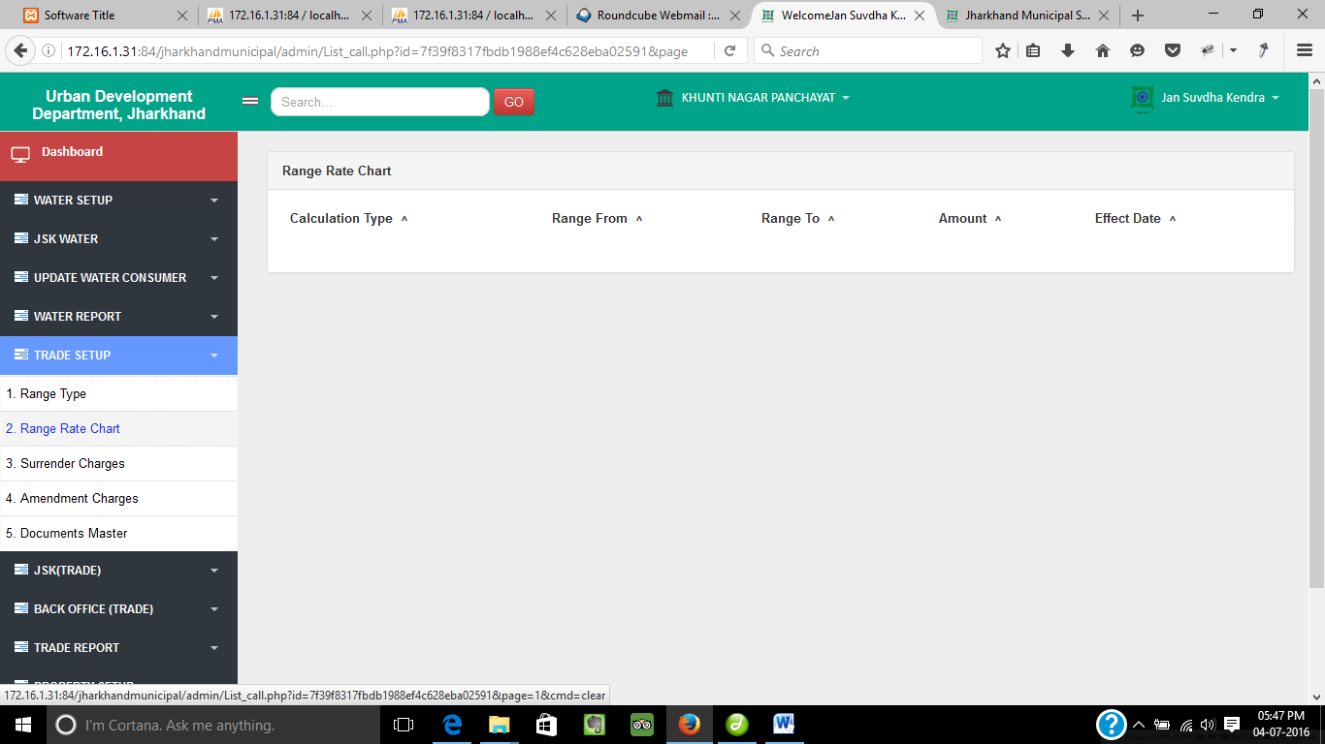

◆

◆

Range Rate Chart…

Click on **Range Rate Chart** to see the listing of range wise rate chart.

Surrender Charges…

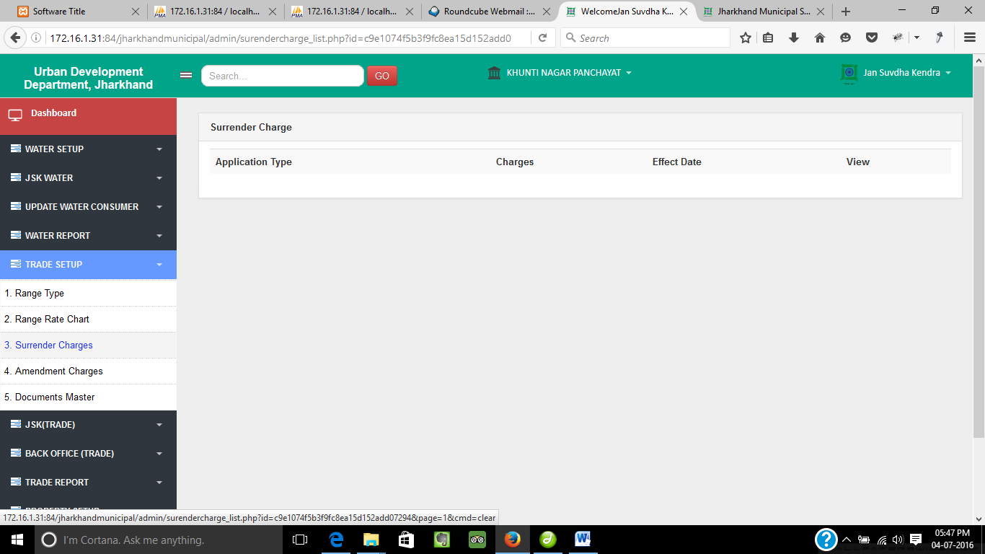

◆

◆

Click on **Surrender Charges** to view the charges for surrender of license.

Amendment Charges…

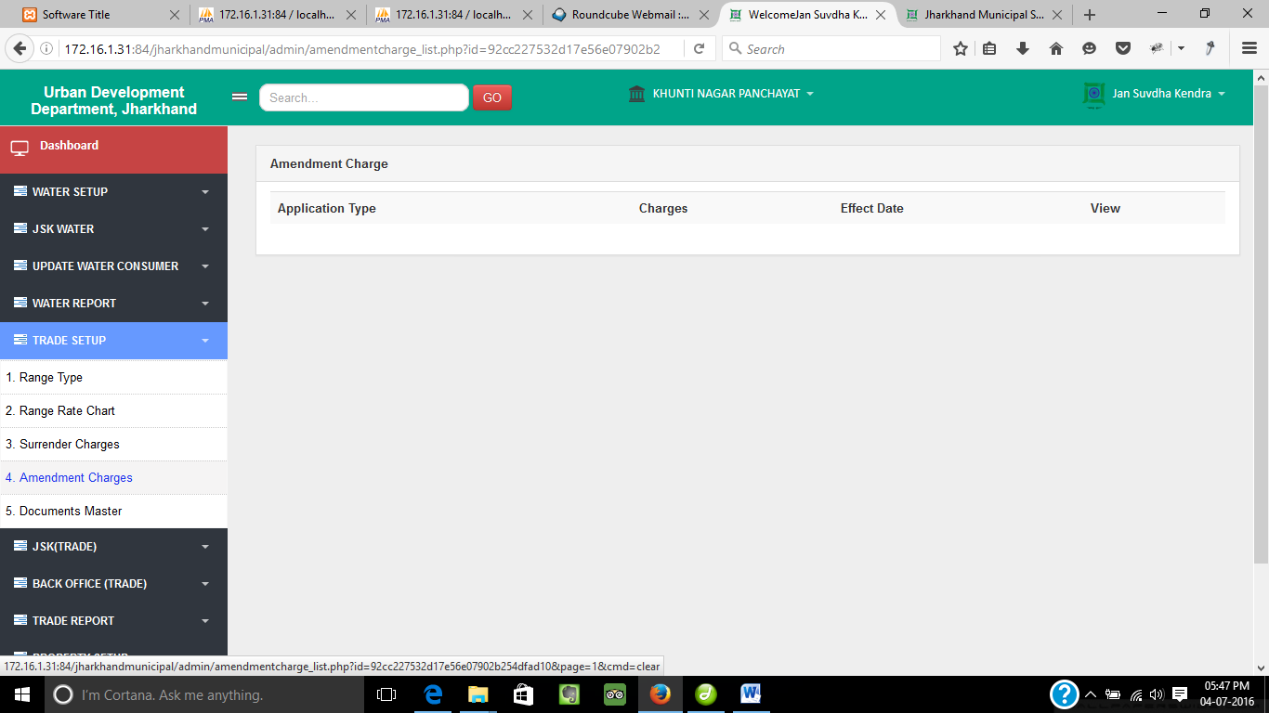

◆

◆

Click on **Amendment Charges** to view the charges for amendment of license.

Document Master…

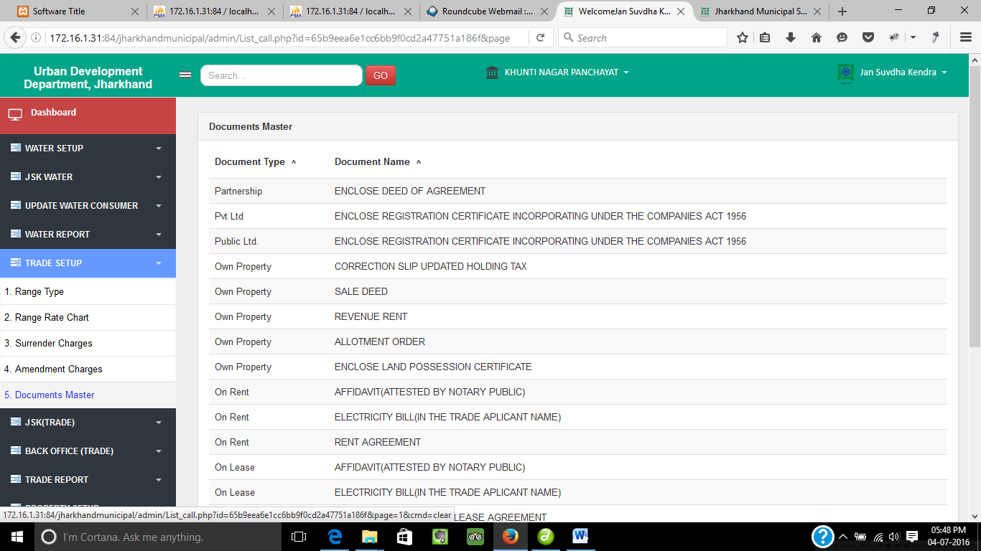

◆

◆

Click on **Document Master** to see the document type.

JSK(Trade)

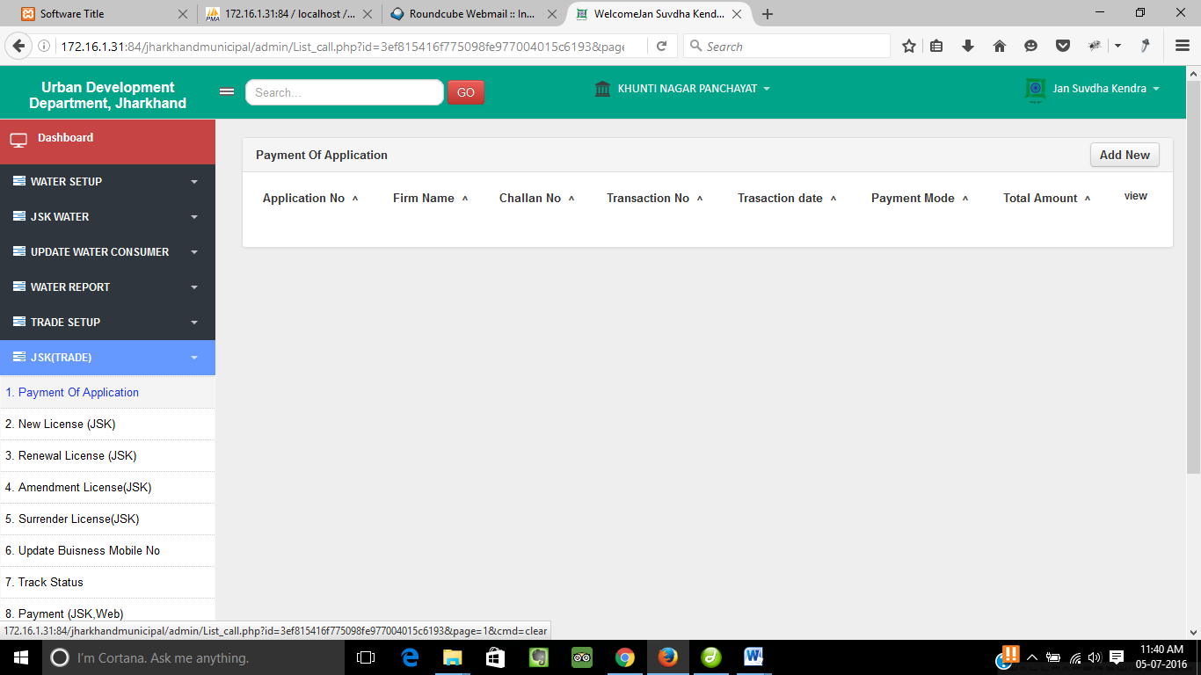

◆

⬥

❖

◆

Payment Of Application…

Click on **Payment Of Application** to see the payment application list.

◆

❖

Click on **Add New** button to add new payment application.

⬥

Click on **View** to see the details of the form.

Add New…

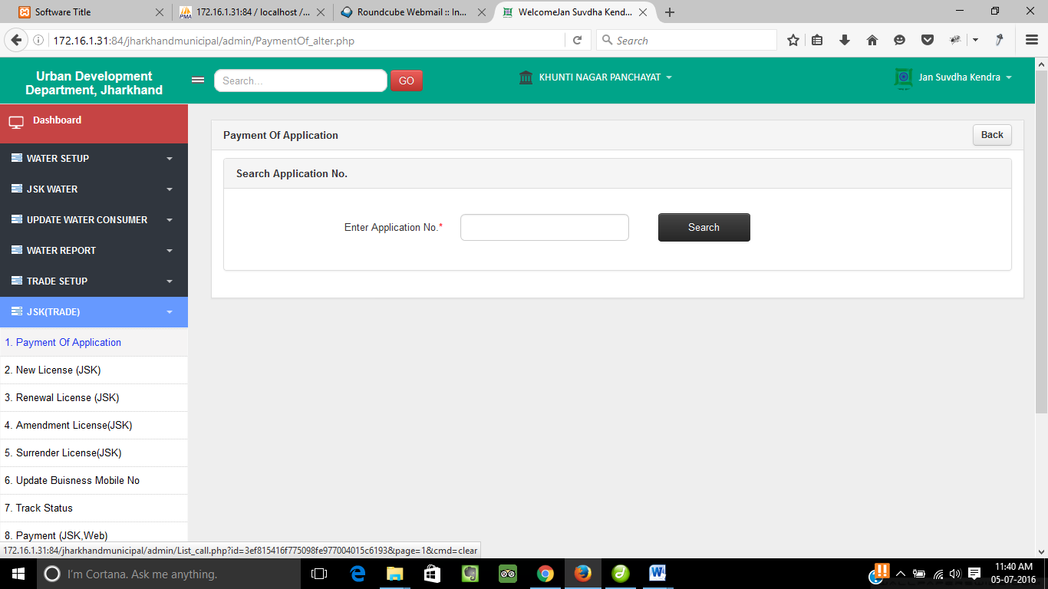

◆

❖

◆

Enter the Application no. of the form and click on **Search** button to get the application form.

   

Click on **Back** button to go back to the previous menu.

Apply For New License…

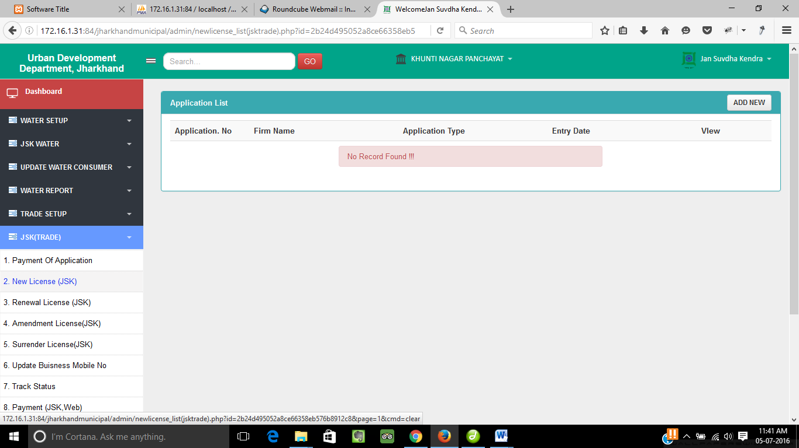

◆

⬥

◆

   

Click on **Apply For New License** to see the list of application for new license.

   

Click on **Add New** button to add new application form.

⬥

Click on **View** to see the details of the form.

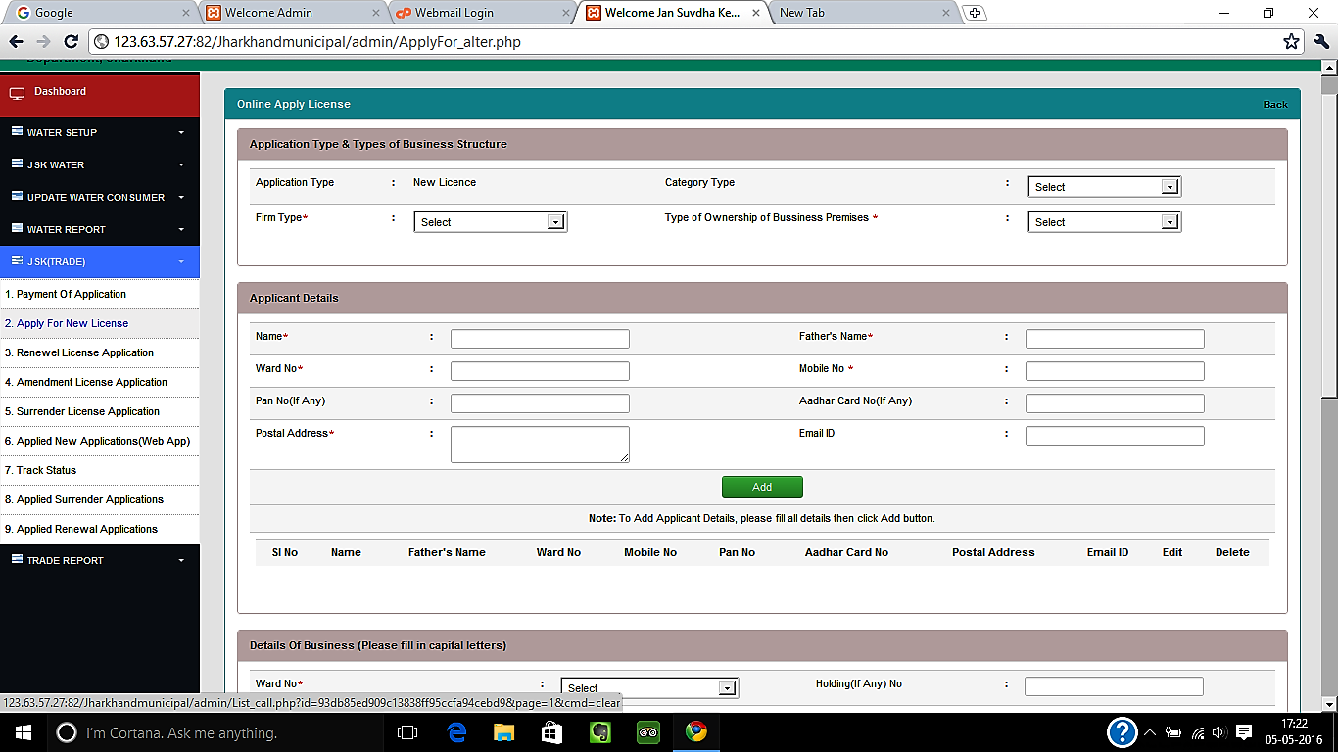

◆

◆

Add New…

Fill up the applicant details form for new license and click add.

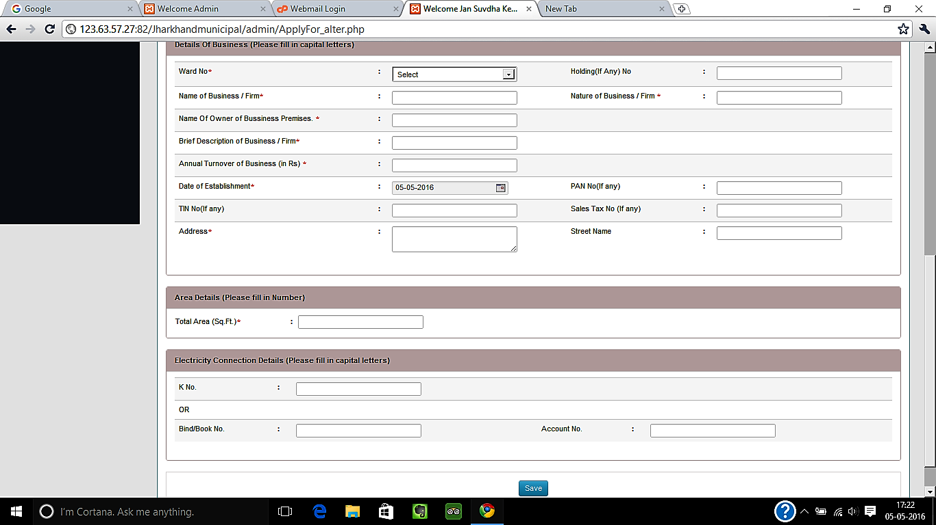

◆

◆

Add New(continued)…

Click Save after completing the other details of the form.

Renewal License Application…

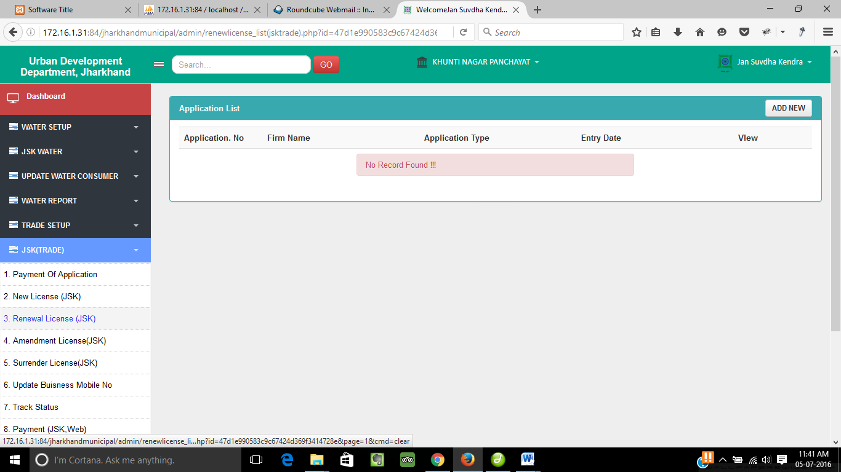

◆

◆

⬥

   

Click on **Renewal License Application** to see the list of application for renewal license.

   

Click on **Add New** button to add new renewal form.

⬥

Click on **View** to see the details of the form.

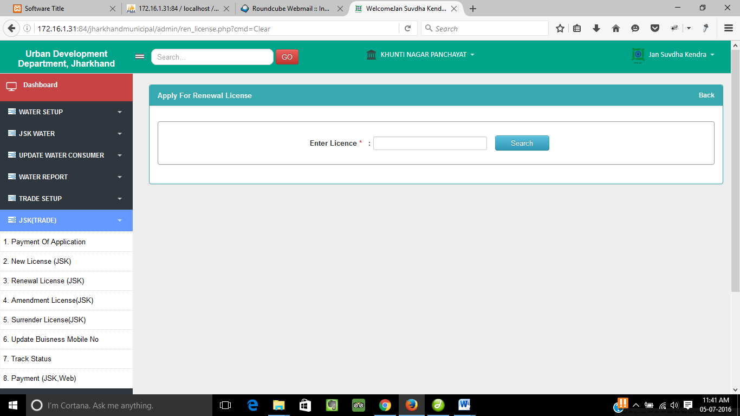

Enter the license no. and click on **Search** button to get the license renewed.

   

◆

◆

Add New…

   

Click on **Back** button to go back to the previous menu.

Amendment License Application…

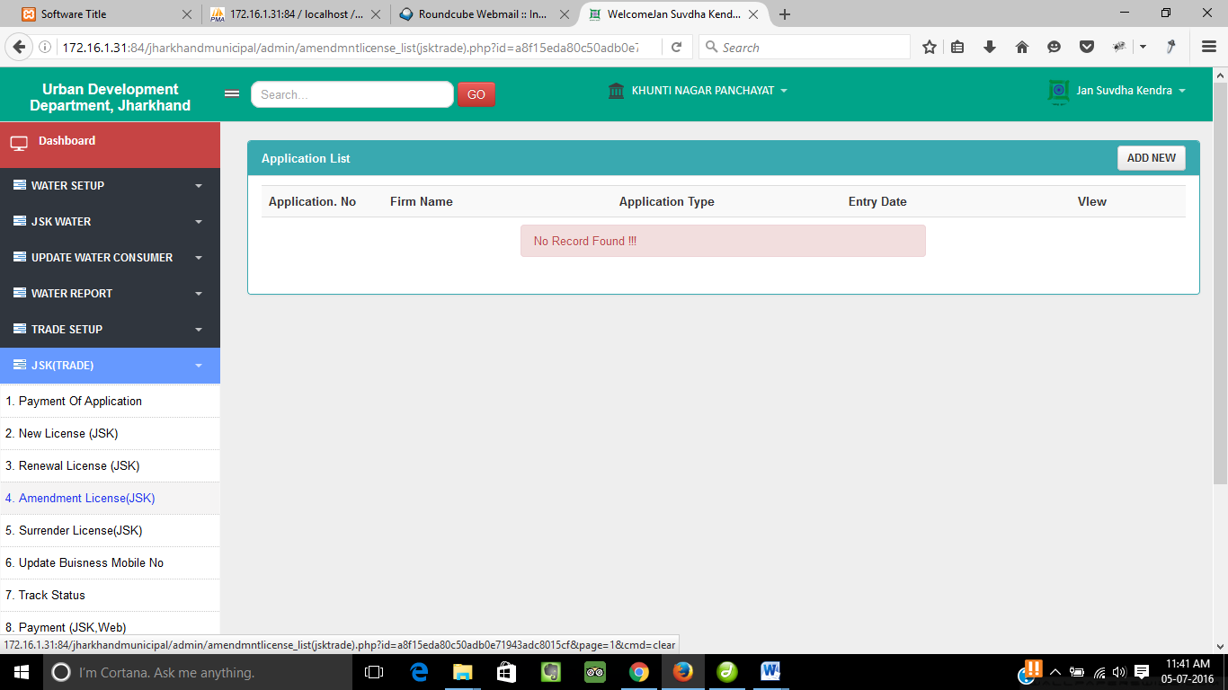

⬥

◆

   

◆

Click on **Amendment License Application** to see the list of amandment license application.

   

Click on **Add New** button to add new amendment license form.

⬥

Click on **View** to see the details of the form.

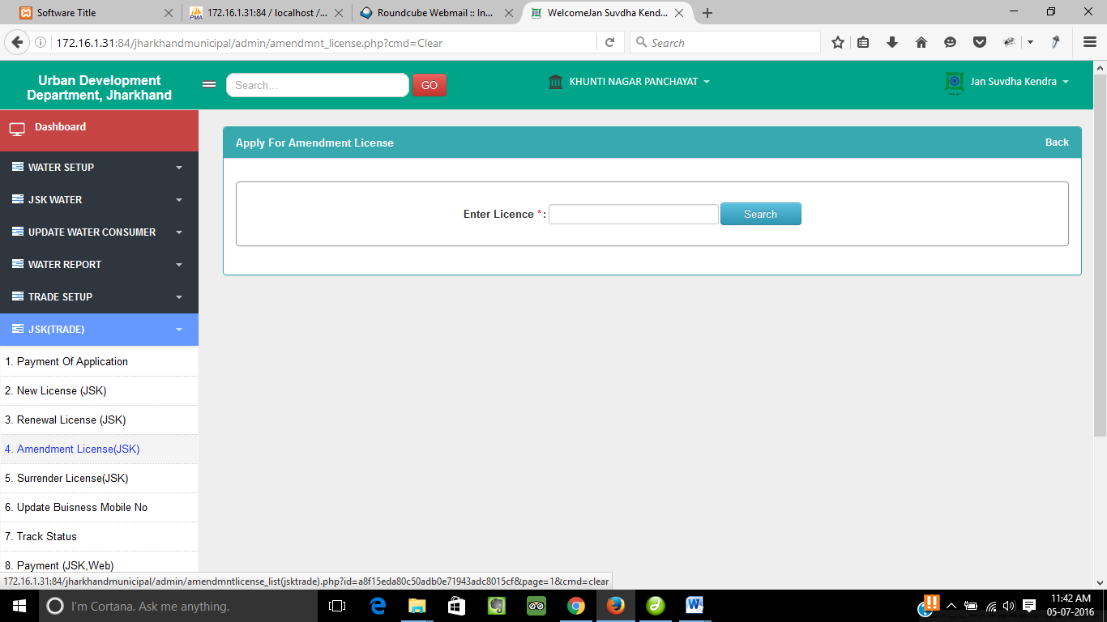

Enter the license no. and click on **Search** button to get the license amended.

   

◆

Add New…

◆

   

Click on **Back** button to go back to the previous menu.

Surrender License Application…

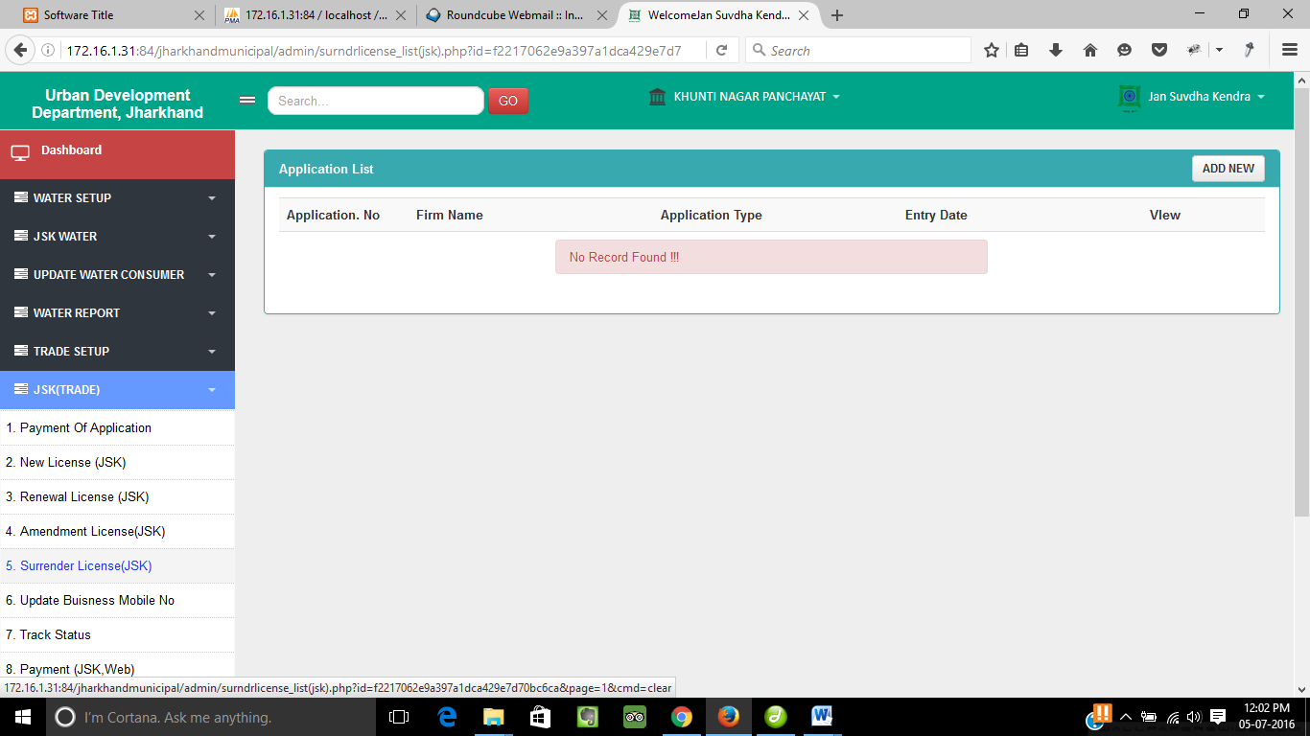

⬥

◆

   

◆

Click on **Surrender License Application** to see the list of surrender license application.

   

Click on **Add New** button to add new surrender license form.

⬥

Click on **View** to see the details of the form.



   

◆

Enter the license no. and click on **Search** button to get the license surrendered.

Add New…

◆

   

Click on **Back** button to go back to the previous menu.

Update Business Mobile No…

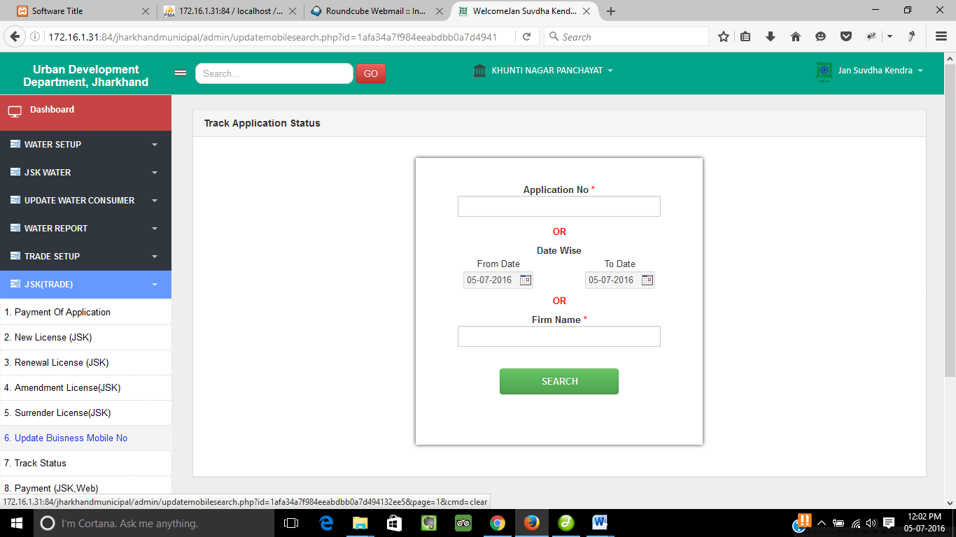

◆

◆

⬥

❖

Click on **Update Business Mobile No.** to track the application status.

❖

Enter the Application No/Date range/Firm Name.

⬥

Click on **Search** button to get the status of the application.

Search…

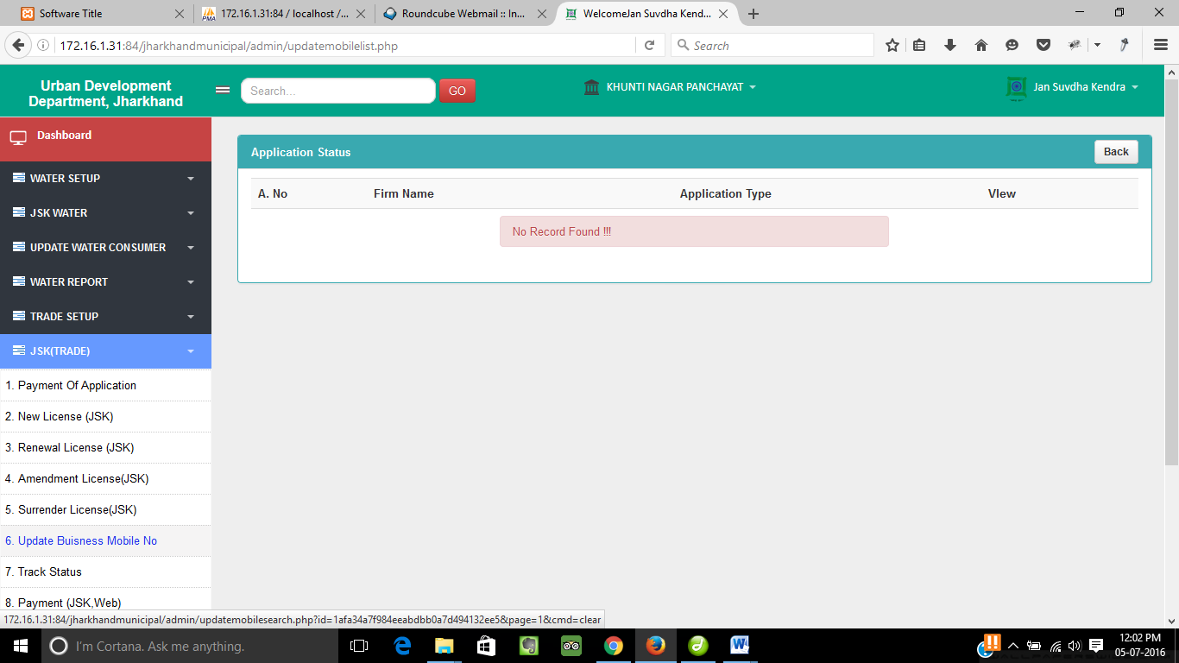

◆

❖

◆

Click on **View** to see the details of individual application.

❖

Click **Back** button to go back to last menu.

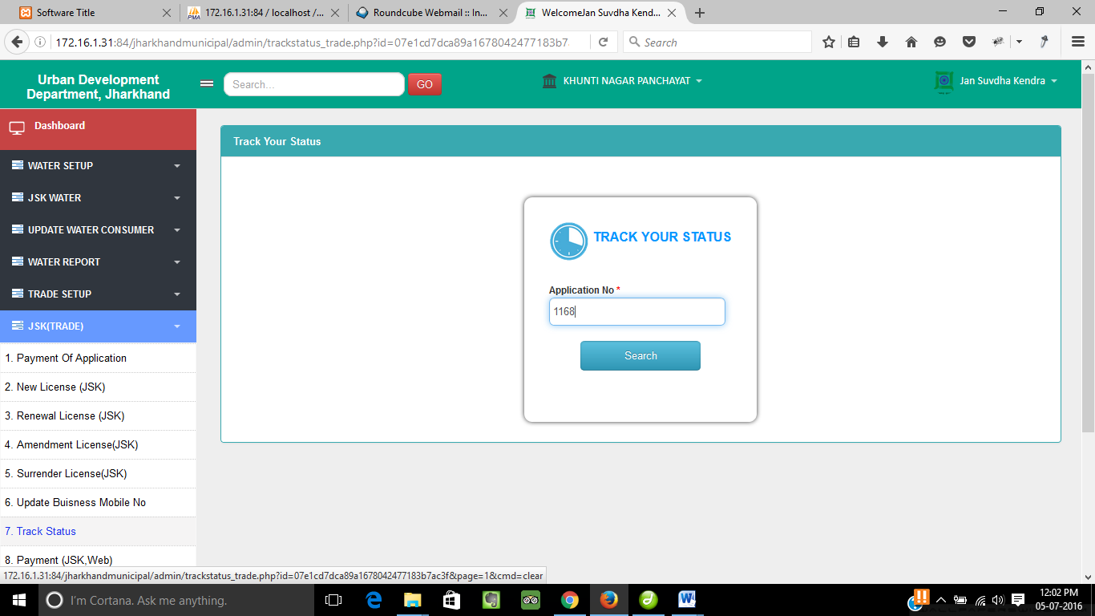

◆

⬥

❖

Track Your Status…

Click on **Track Status** to track the application status.

 

❖

Enter the Application No.

⬥

Click on **Search** button to get the status of application.

Payment…

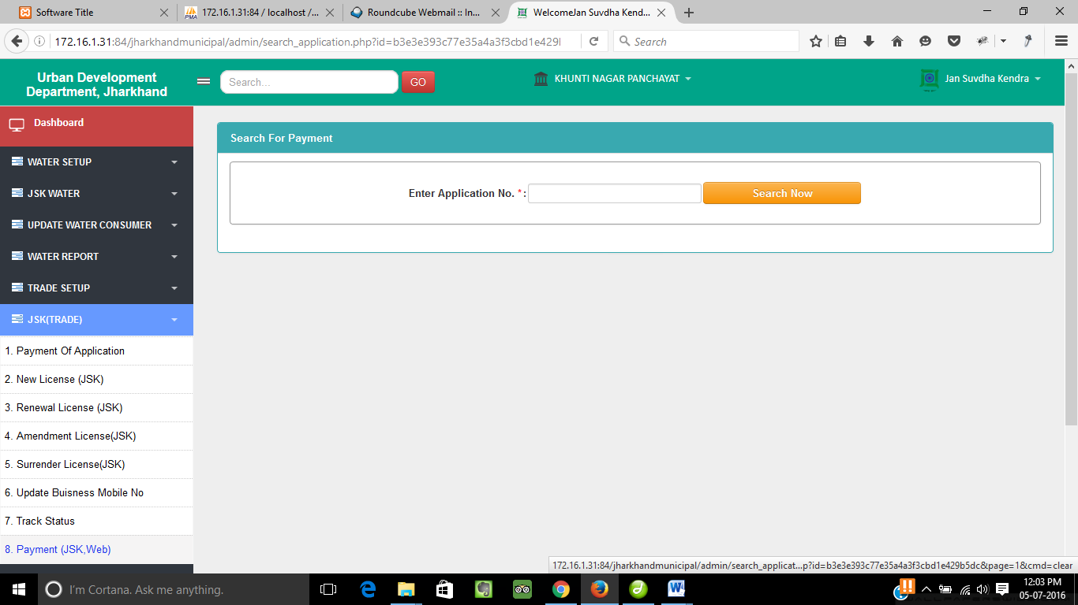

❖

◆

◆

Click on **Payment(JSK, Web)** to track the application status.

❖

Enter the Application No and Click on **Search** button to get the status of the application.

Back Office (Trade)

Apply For New License…

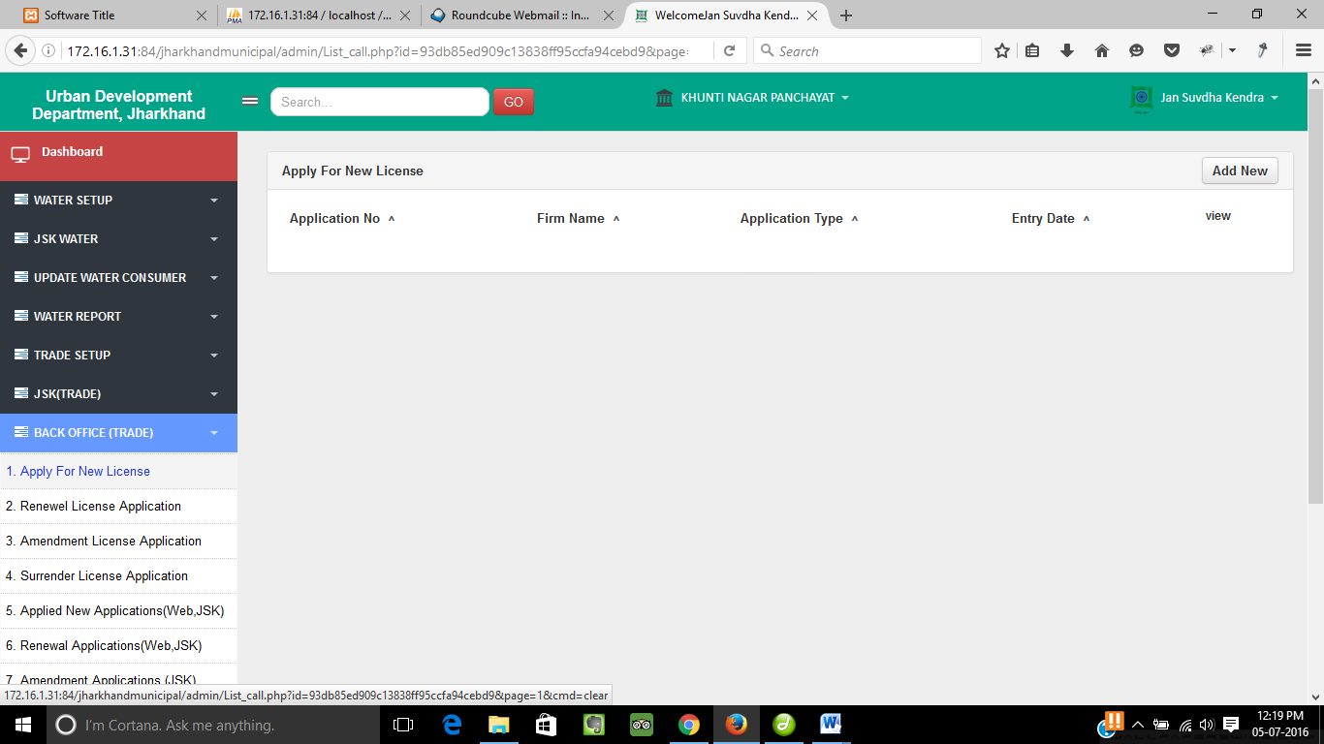

◆

⬥

   

◆

Click on **Apply For New License** to see the list of application for new license.

   

Click on **Add New** button to add new application form.

⬥

Click on **View** to see the details of the form.

Renewal License Application…

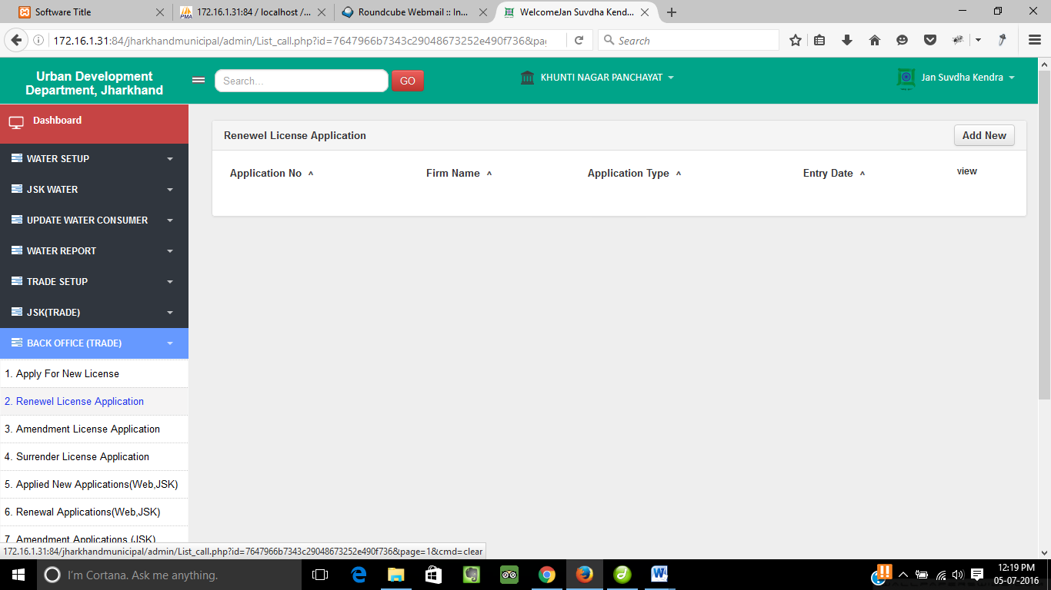

⬥

   

◆

◆

Click on **Renewal License Application** to see the list of application for renewal license.

   

Click on **Add New** button to add new renewal form.

⬥

Click on **View** to see the details of the form.

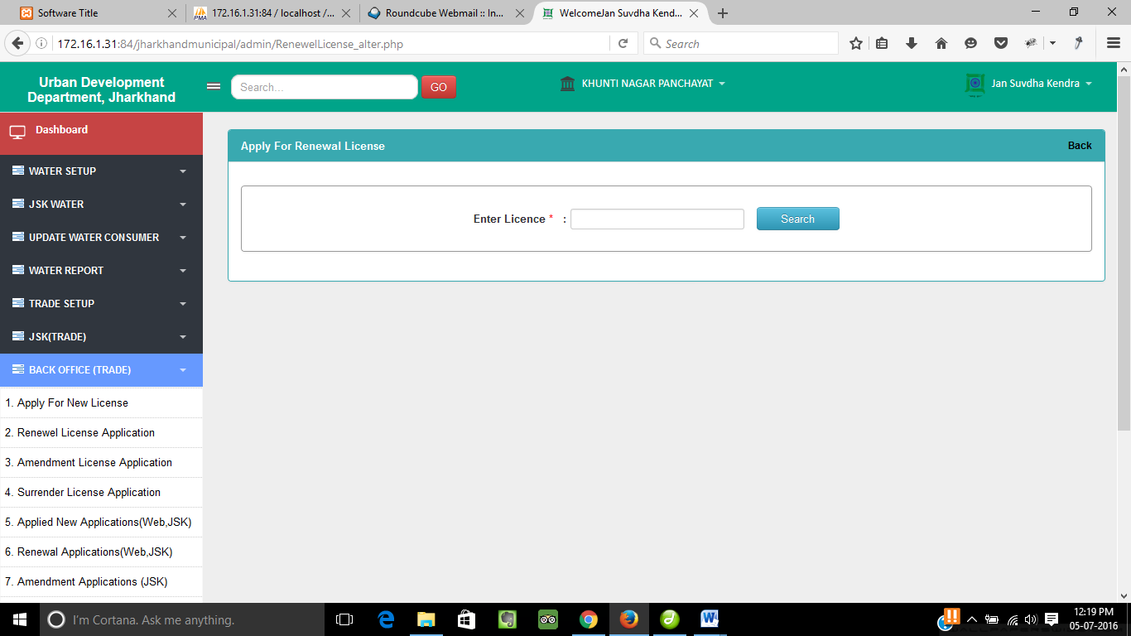

◆

   

Add New…

Enter the license no. and click on **Search** button to get the license surrendered.

◆

   

Click on **Back** button to go back to the previous menu.

Amendment License Application…

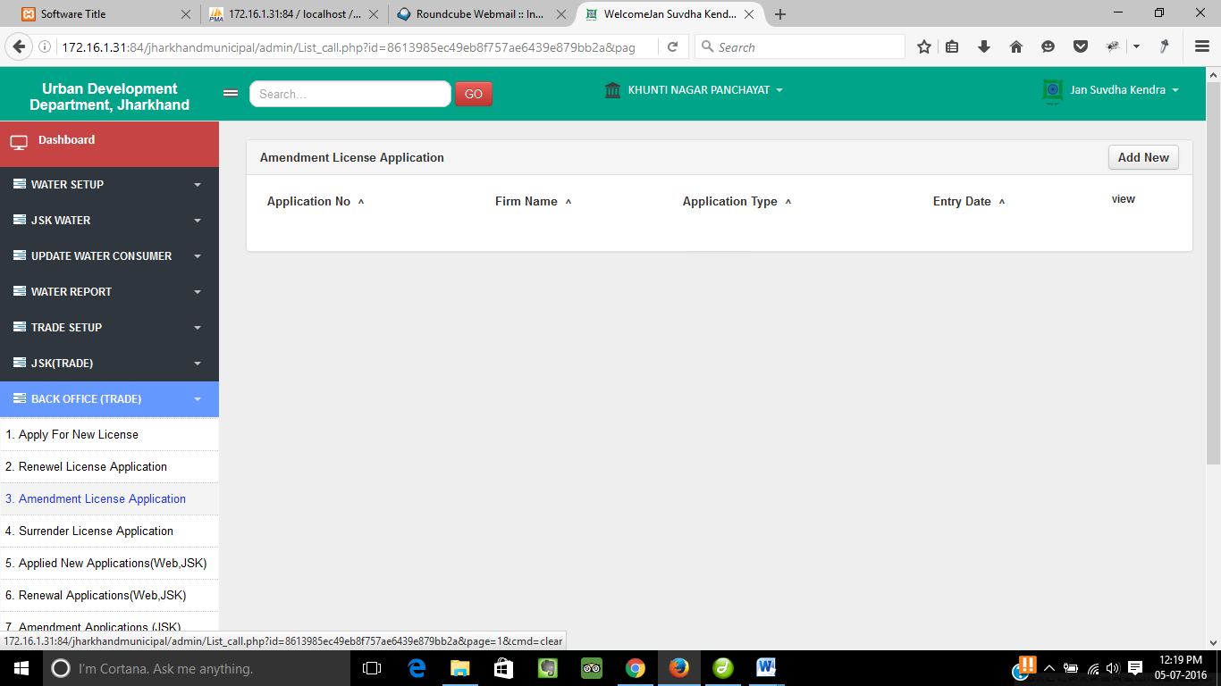

⬥

   

◆

◆

Click on **Amendment License Application** to see the list of amendment license application.

   

Click on **Add New** button to add new amendment license form.

⬥

Click on **View** to see the details of the form.

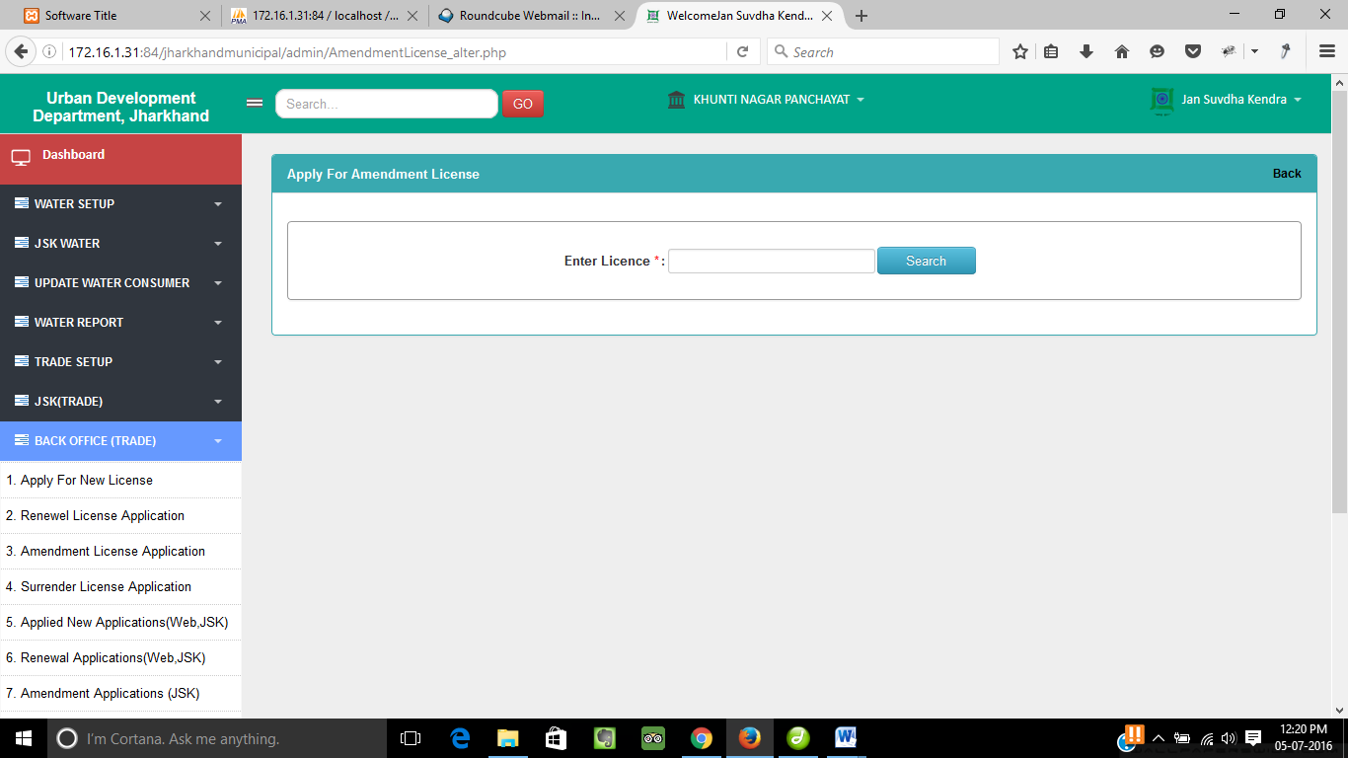

Add New…

   

◆

Enter the license no. and click on **Search** button to get the license surrendered.

◆

   

Click on **Back** button to go back to the previous menu.

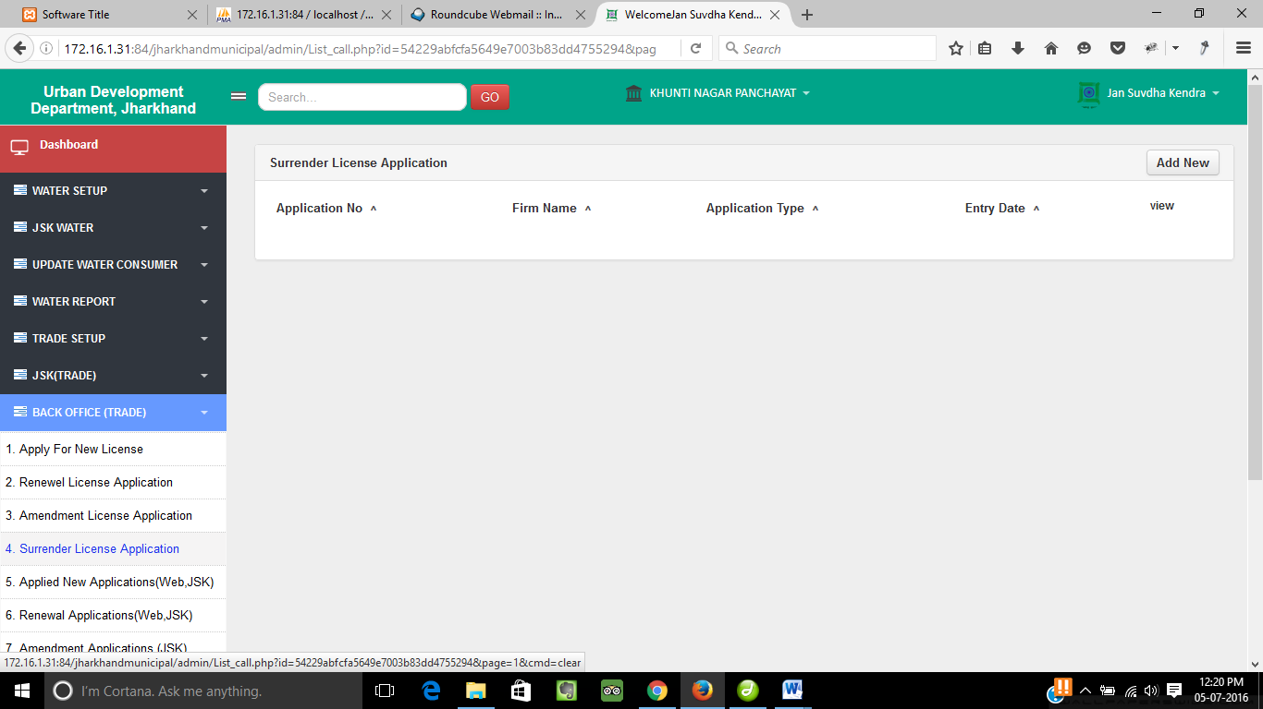

⬥

   

◆

Surrender License Application…

◆

Click on **Surrender License Application** to see the list of surrender license application.

   

Click on **Add New** button to add new surrender license form.

⬥

Click on **View** to see the details of the form.

Surrender License Application…

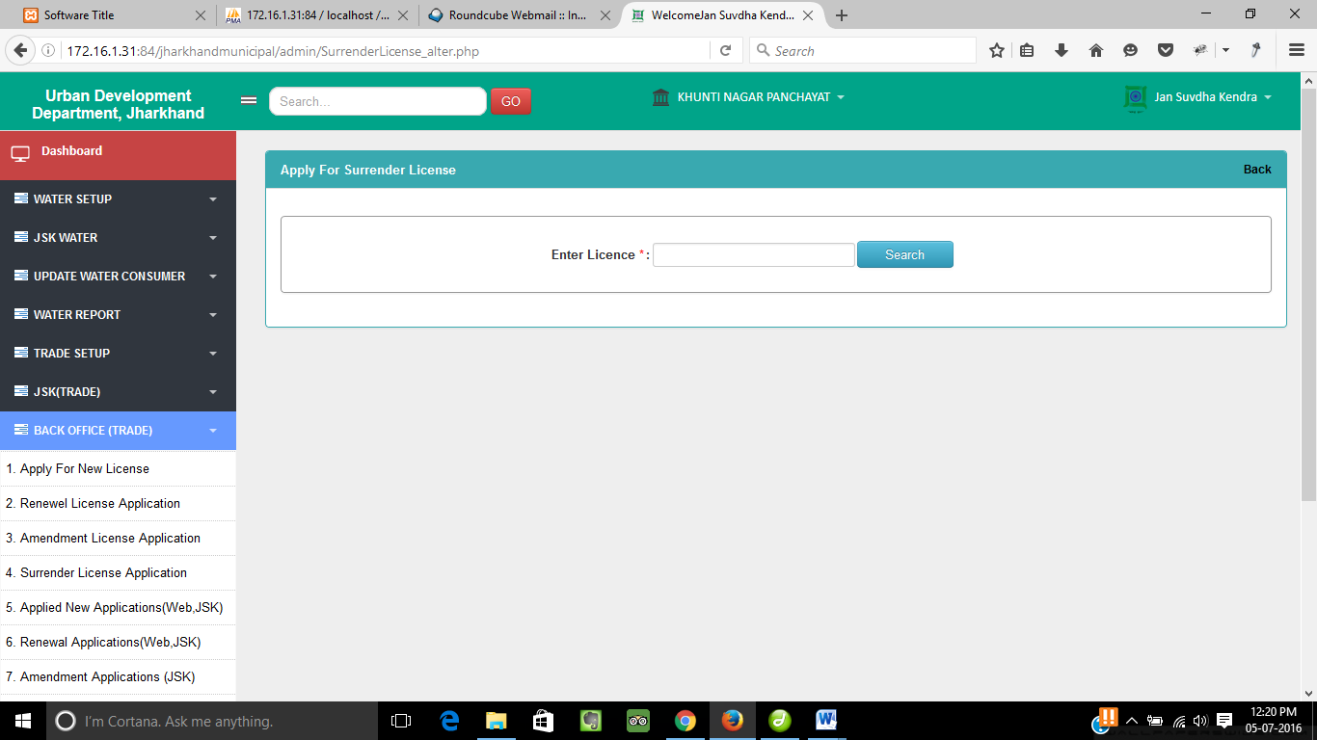

   

◆

Enter the license no. and click on **Search** button to get the license surrendered.

◆

   

Click on **Back** button to go back to the previous menu.

Applied New Applications(Web/JSK)…

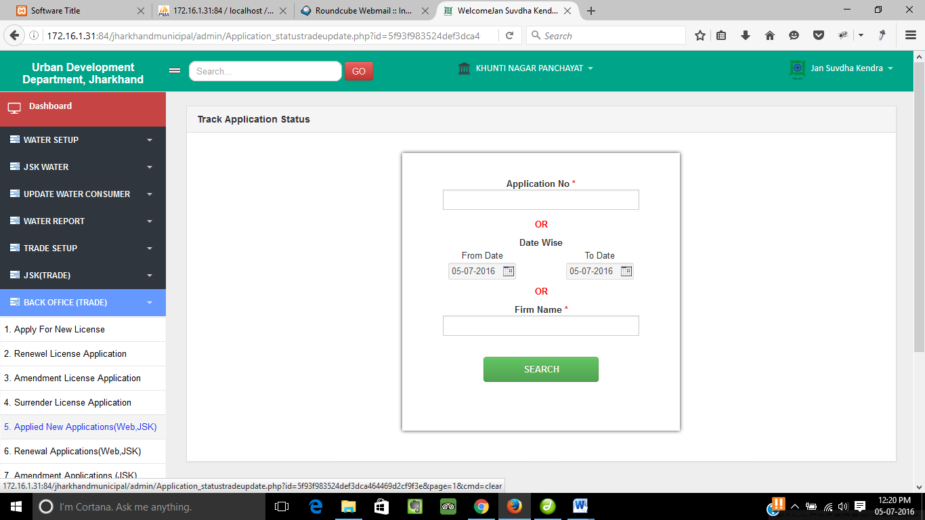

⬥

❖

◆

◆

Click on **Applied New Application(Web/JSK)** to track the application status.

❖

Enter the Application No/Date range/Firm Name.

⬥

Click on **Search** button to get the status of the application.

Search…

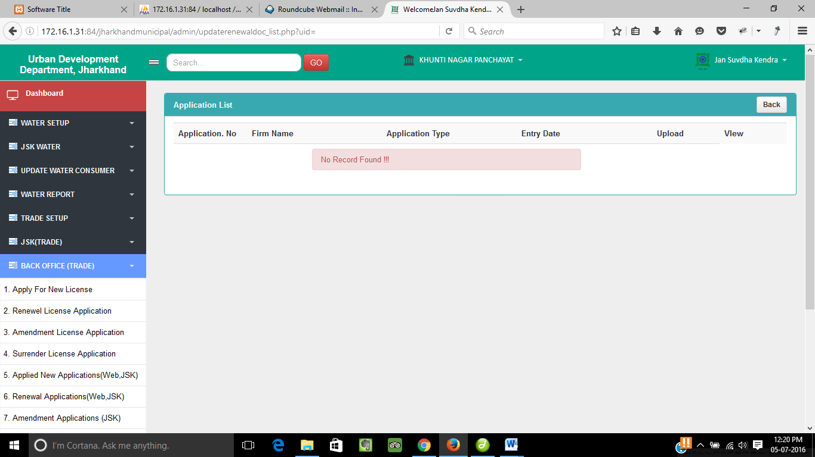

   

◆

Click on **View** to see the details of the form.

◆

   

Click on **Back** button to go back to the previous menu.

Amendment Applications(Web/JSK)…

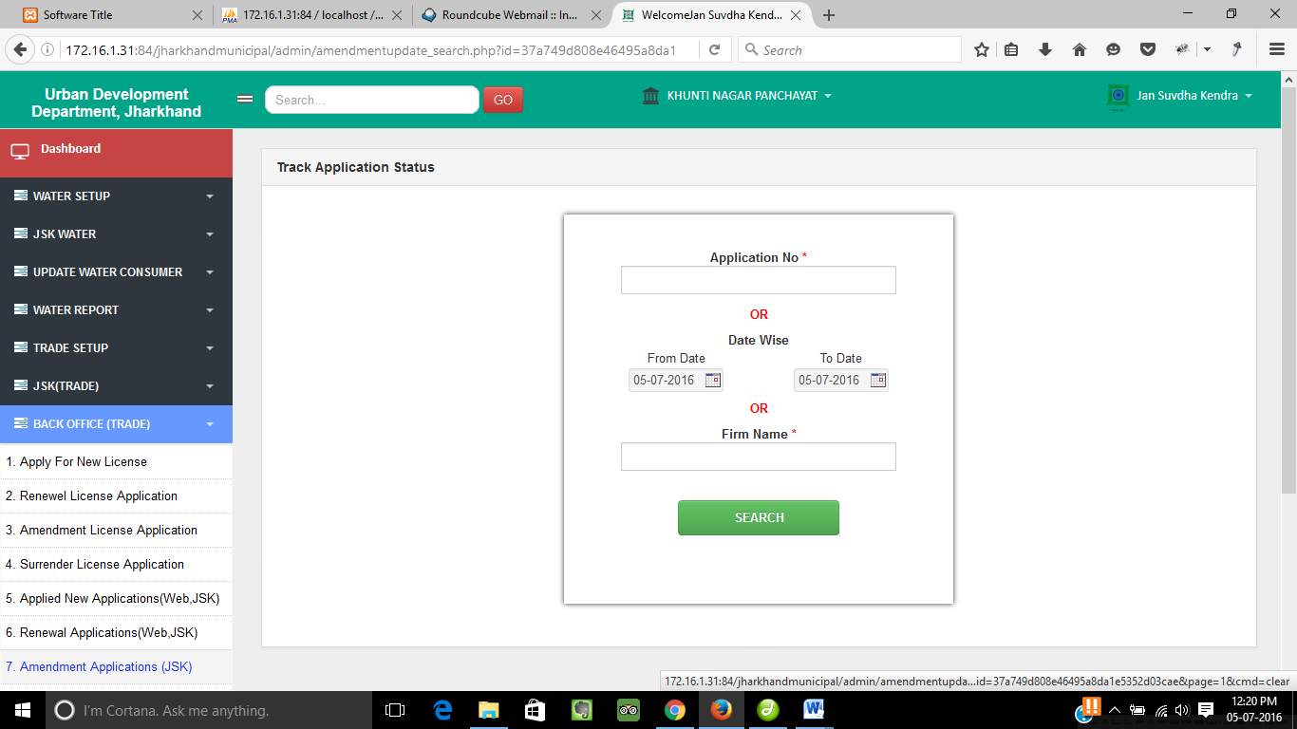

⬥

❖

◆

◆

Click on **Amendment Application(Web/JSK)** to track the application status.

❖

Enter the Application No/Date range/Firm Name.

⬥

Click on **Search** button to get the status of the application.

Surrender Applications(Web/JSK)…

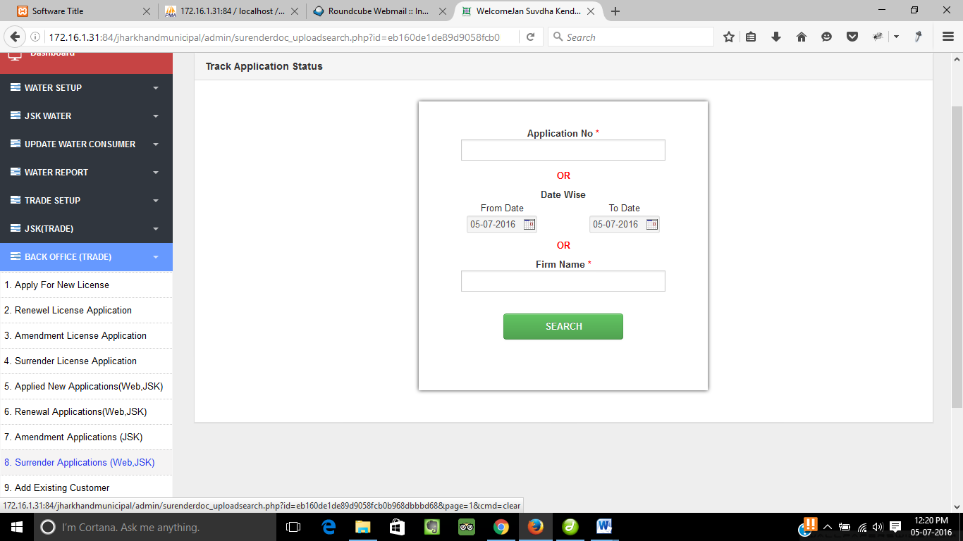

⬥

❖

◆

◆

Click on **Surrender Application(Web/JSK)** to track the application status.

❖

Enter the Application No/Date range/Firm Name.

⬥

Click on **Search** button to get the status of the application.

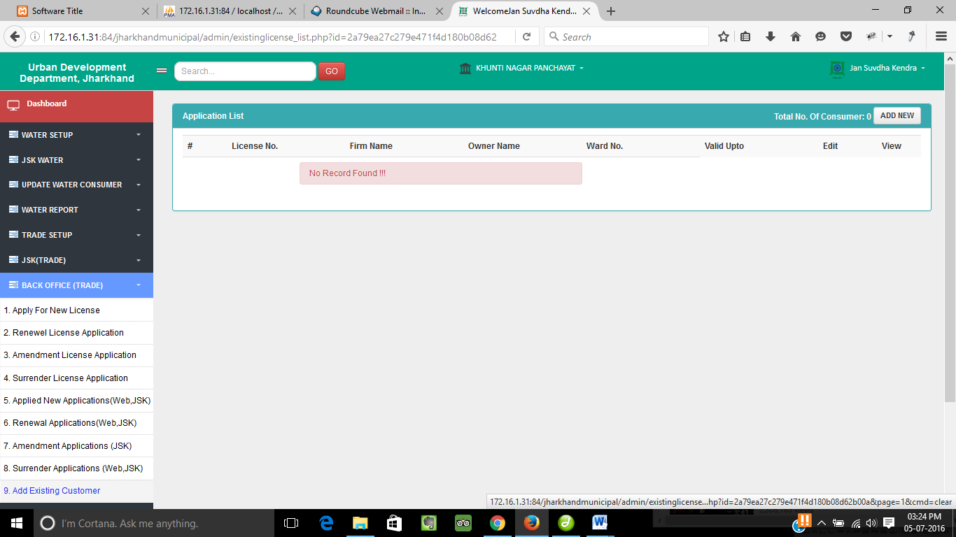



⬥

❖

◆

◆

Click on **Add Existing Customer** to add the details of existing customer.

❖

Click on **Add New** to add existing customer.

⬥

Click on **Edit** to make changes of the form.

Click on **View** to see the details of the form.



Trade Report

Counter Report…

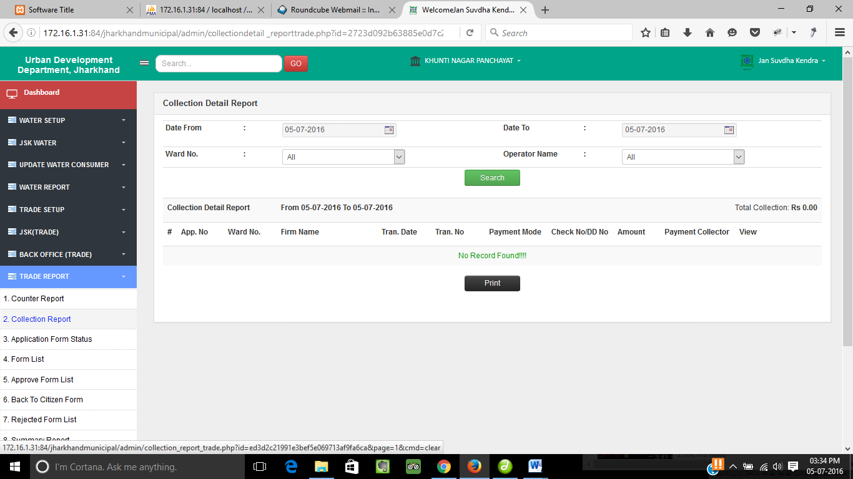



 

 

****

⬥

❖

Click on **Counter Report** to see the counter report details.

❖



⬥

Enter the date range, ward no. and operator name from the dropdown.

Click on **Search** button to get the details of the choosen fields.

Click on **Print** to take a print copy of report.

****

Click on **View** to see the details of the application form.

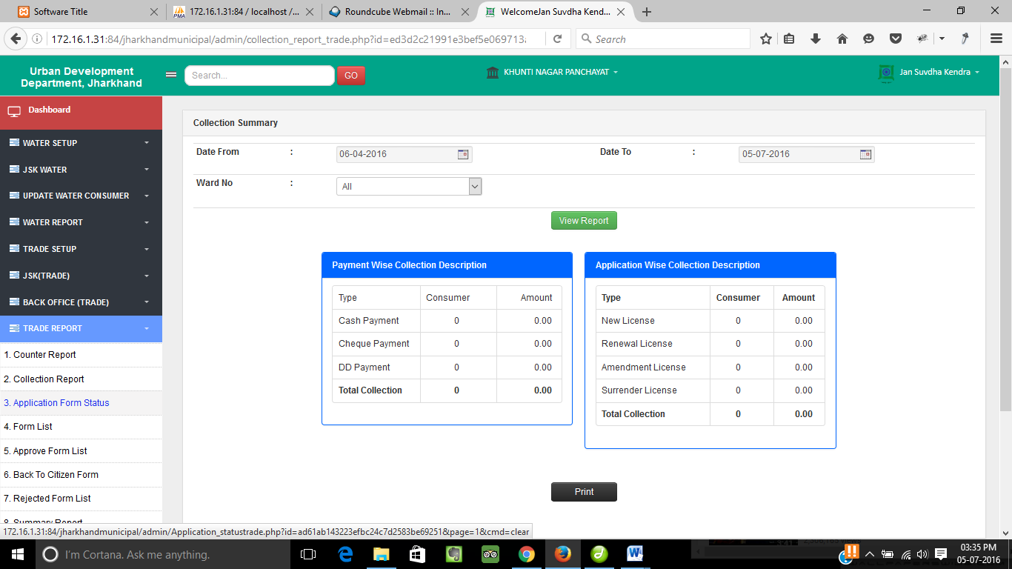

 



⬥

❖

 

Collection Report…

Click on **Collection Report** to see the collection report details.

❖



⬥

Enter the date range and ward no. from the dropdown.

Click on **View Report** button to get the payment details of the choosen fields.

Click on **Print** to take a print copy of report.

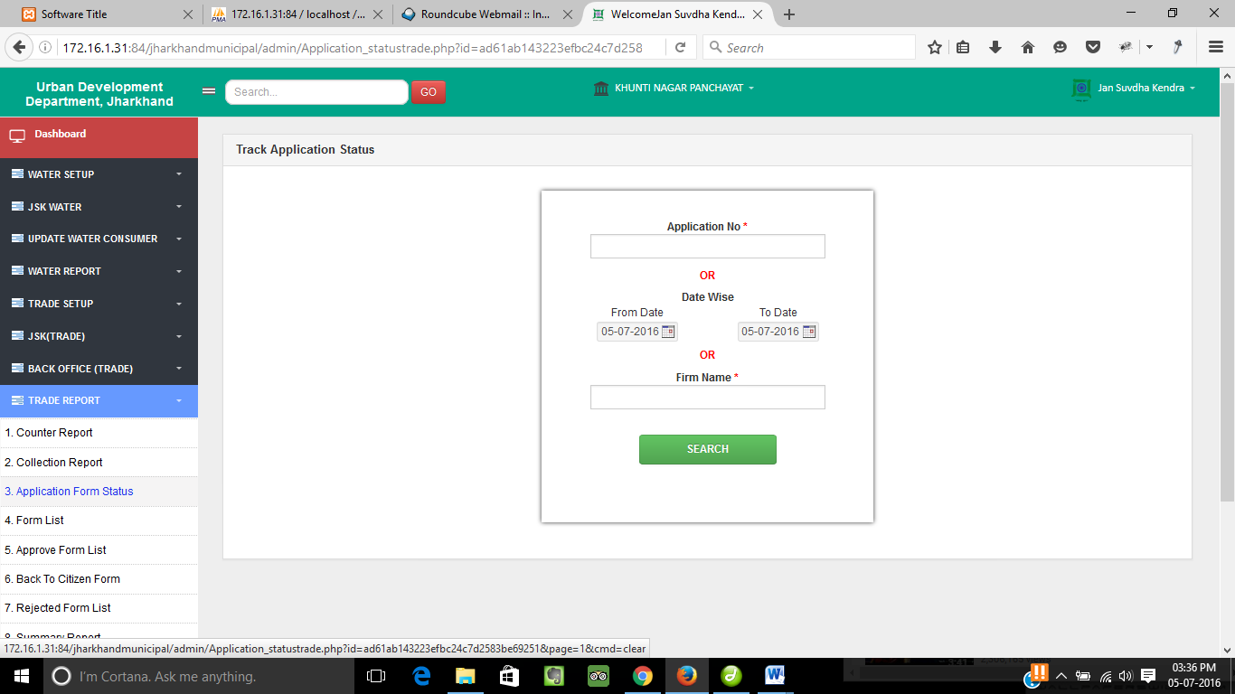

 

⬥

 

❖

Application Form Status…

Click on **Application Form Status** to track the application status.

❖

Enter the Application No/Date range/Firm Name.

⬥

Click on **Search** button to get the status of the application.

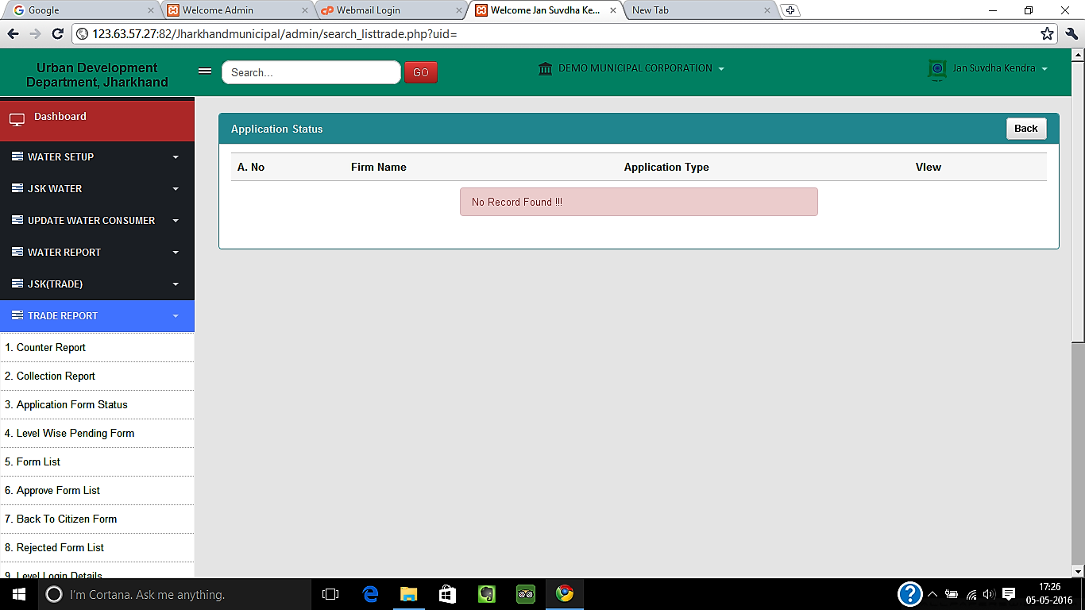

❖

 

Search…

 

Click on **View** to see the details of individual application.

❖

Click **Back** button to go back to last menu.

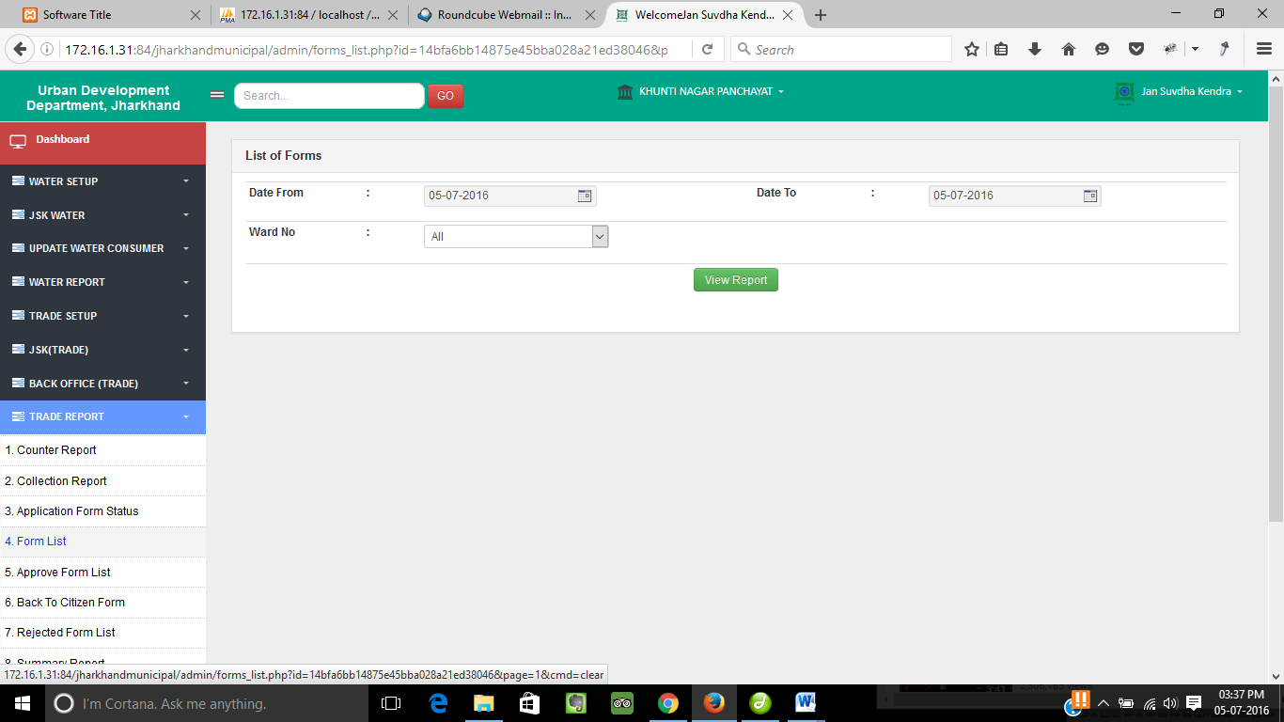

 

❖

 

⬥

Form List…

Click on **Form List** to see the list of forms.

❖

Enter the date range and ward no. from the dropdown.

⬥

Click on **View Report** button to see the list of forms.

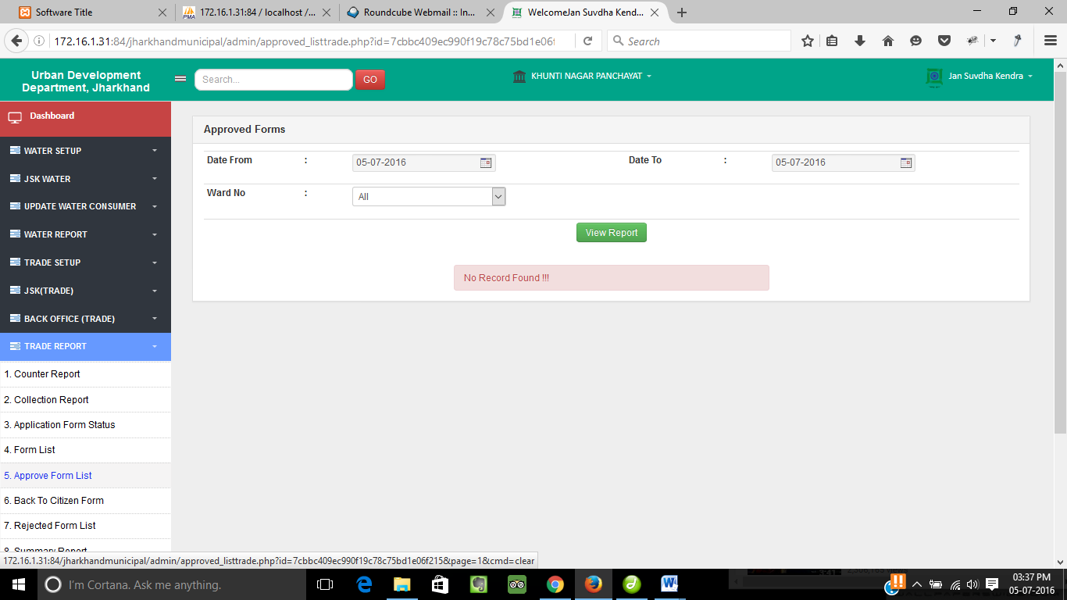

 

 

⬥

❖

Approved Form List…

Click on **Approved** **Form List** to see the approved forms.

❖

Enter the date range and ward no. from the dropdown.

⬥

Click on **View Report** button to get the list of approved forms.

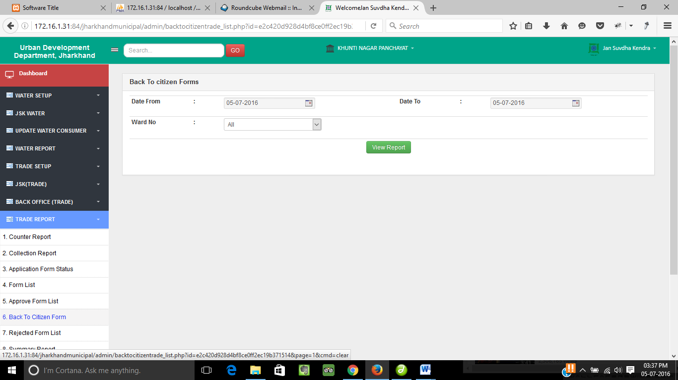

 

 

⬥

❖

Back To Citizen Form…

Click on **Back To Citizen Form** to see the forms sent back to the citizen.

❖

Enter the date range and ward no. from the dropdown.

⬥

Click on **View Report** button to get the list of forms sent back to the citizen.

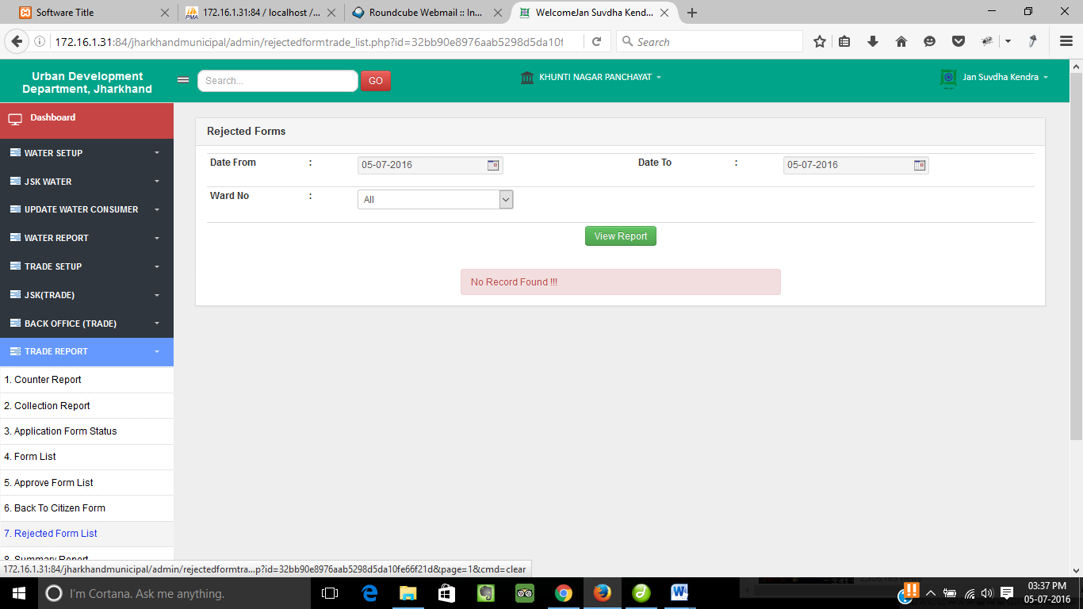

 

❖

⬥

 

Rejected Form List…

Click on **Rejected** **Form List** to see the rejected forms.

❖

Enter the date range and ward no. from the dropdown.

⬥

Click on **View Report** button to get the list of rejected forms.

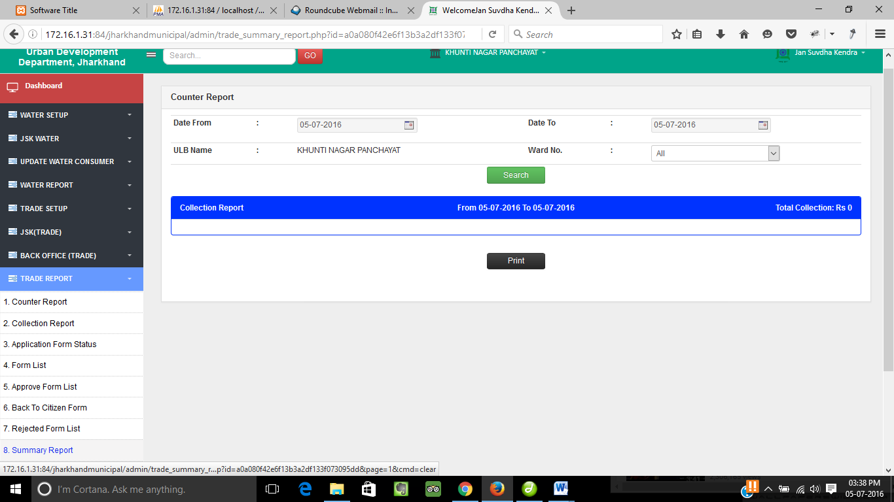

❖

Summary Report…

Click on **Summary Report** to see the details of all ULB wise wards.

⬥



 

 

❖

Enter the date range and ward no. from the dropdown.

⬥

Click on **Search** button to get the ULB wise collection report.



Click on **Print** to take a print copy of report.

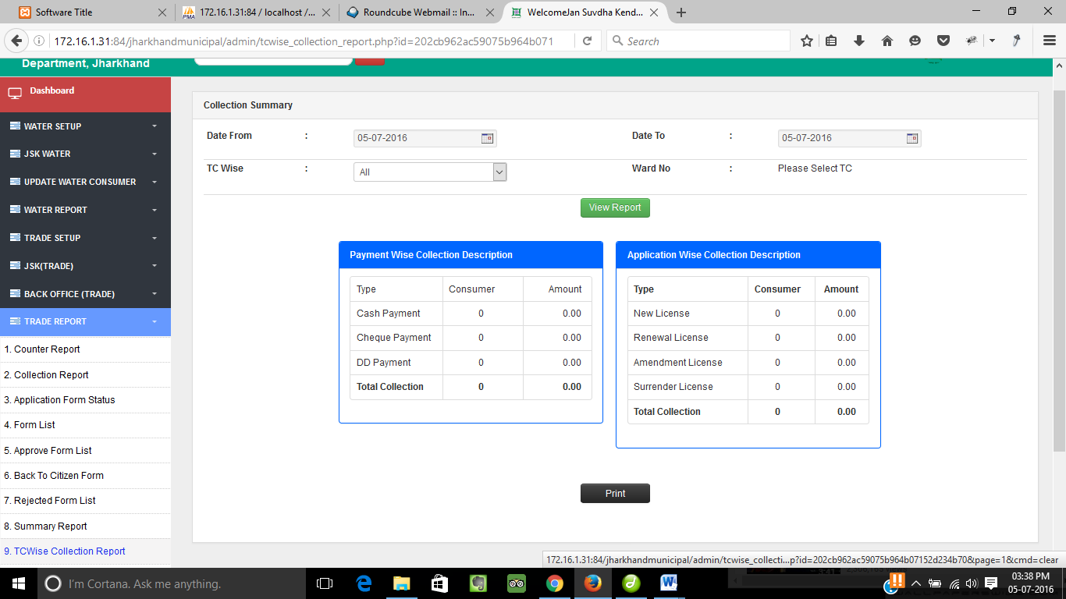

 

 



❖

⬥

TC Wise Collection Report…

Click on **TC Wise Collection Report** to see the TC wise collection summary.

❖

Enter the date range and TC wise. from the dropdown and ward no. when TC is selected.

⬥

Click on **View Report** button to get the summary of payment wise collection.



Click on **Print** to take a print copy of report.

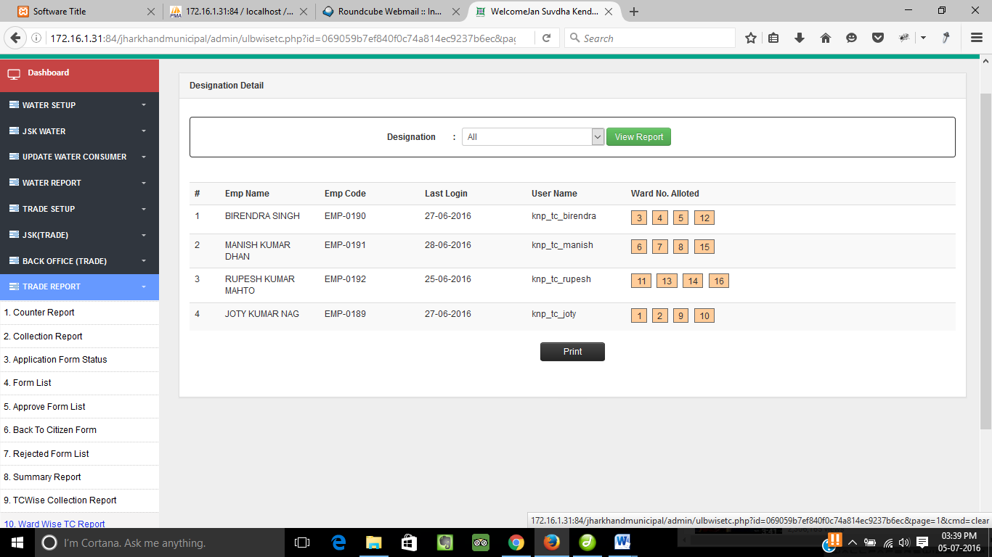

⬥

❖

 

TC Login Details…

 

Click on **TC Login Details** to see the details of the TC login.

❖

Select the desination from the dropdown and Click on **View Report** button to get the details of the selected designation(TC) .

⬥

Click on **Print** to take a print copy of report.

F:\Kunal\Images\logo.png

SSPL